Updated Information on Printing With LogPrint
Contents:
Printing single QSO labels version 03/27/13:1
Printing multiple QSOs labels
Printing full QSL card with QSO data
Glossary of LogPrint errors and their probable solutions

Introduction:
The purpose of the LogPrint software is to provide Logger32 with a set of basic print routines for the hard copy printing of the log and the making of QSL labels. It also allows the user to create their own QSL card as a blank or one filled in by the computer as the card prints. I am not the author of LogPrint nor did I write the original Helpfile for it. The framework or original concept for LogPrint was developed by J.B. Edmonds – N4NQY and later modified with the program actually being written by Charles Sutton - W1MCP. An excellent Helpfile document was written by Geoff Anderson - G3NPA and is included in the download of the LogPrint program available under the Utility section of http://www.logger32.net/ under the sub-heading “LogPrint & QSO Map by W1MCP”. The Logger32.net website has been recently redesigned and as this article is being written, LogPrint can be found at: http://www.logger32.net/utilities.html#.UUoGKRe_N8E

The program has a number of built-in features to make it very versatile but some folks find it difficult to fully implement these features. In particular is the feature that allows the user to print a single, larger label that includes several different QSO entries with the same station. This might be the case where the user had contacted a DXpedition on several bands and/or modes or perhaps just a station with whom they had made multiple contacts. The contact data for these QSOs does not need to be grouped together in the .adi file but LogPrint will gather them from the file, sort them together and send them to the printer as a group so the single label displays them all (see example below).

This article is an update for a previous article listed on my website and written back in 2007. That article, http://www.hayseed.net/~jpk5lad/LogPrint%20Labels/LogPrint.htm , titled ”LogPrint Multiple Label Suggestions” was quite well received and I found it referenced and recommended by numerous other website authors over the Internet. The original setup made no exceptions for multiple modes and/or verifying some contacts from cards the other station had already sent but requesting confirmation for other contacts with that same station. The new version listed in this article can print these mixed modes and mixed confirmations such as those shown below:
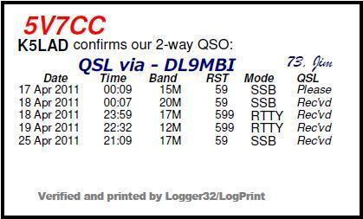 |  | Under the Mode column, it is possible to identify different modes.  Under the QSL column you can see four items marked “Rec’vd” for several QSOs but a request “Please” for another contact. The previous setup article would find the first mode listed and first confirmation listed and duplicate it for every label entry.
Each copy of LogPrint allows the user to have available three different setups for labels. The previous article referred to only the printing of a label with multiple QSOs whereas this article adds my setup information for printing all three: a smaller label for a single QSO confirmation, printing a full QSL card with ADIF data taken from the file created by Logger32 and inserted into the proper places on the card, as well as the modified setup for a label showing multiple QSOs with the same station. Note that the LogPrint Helpfile also has some setup examples to give you additional ideas.

Although my original article did not show my setup for my single QSO labels, I also modified my new option to add a “QSL via - ______” line in the lower right corner of the label. The logic for both label options is – if no QSL via or QSL manager is listed in my Logger32 then none will be exported to the .adi file so nothing is printed in the designated space for that information. Since the ARRL Outgoing QSL Bureau wants you to send your cards to them sorted alphabetically by the station who is to receive the card (whether it’s the actual station contacted or their QSL Manager) it is especially handy to list that information on the label if it’s available.
In addition to these, I have shown several of the error messages that a user might encounter with LogPrint, what those errors mean, as well as a way to correct the setup that has caused the error. This section may be the best part; worth its weight in gold and may save the user much time and frustration.

When this section was written, the current version of LogPrint was version 3.1.2. It’s possible that even this might be updated but the program is, at this time, a mature program and is quite complete in this current version. I would not hold my breath, waiting for an updated version. It reminds me of the old programmer’s adage which said, “A computer program is never finished…….. you just get tired of working on it.”

If you plan to use the features of this updated setup for LogPrint, it is advisable to go back to the original article and spend some time studying it. It goes into more detail about how the data values in the program’s setup affect the printed output. You need to understand this before using the modifications set forth in this update. As mentioned previously, it is located at http://www.hayseed.net/~jpk5lad/LogPrint%20Labels/LogPrint.htm

Updated article information:
Some of the items mentioned here, such as setting up "Your Information" and choosing the printer will usually only need to be done once and will only need changing if it requires some modification. The values you choose and enter are saved to the LogPrint.ini file and are available each time the program is restarted.

The following is done to choose the printer to be used:
Check the pull-down menu from File and choose "Printer SetUp." The list of printers shown is taken from those already installed on your local Windows computer. If you are on a network and one or more network printers are installed, they will show up in this list also. Choose the printer you plan to use from the list of printers. If you do not currently have a printer available and just want to see what your LogPrint output looks like printed out as a PDF file, choose PDF995 from your list (see NOTE 1 below for instructions on locating and installing this program).

The following is done to set up your information to be used:
Click on LogPrint "SetUp" and choose the top line, “Your Information”
Fill in the information requested, your call and the sharable part of your address you want to use. Note that there is not a box for a name, only call and addresses.

The following is done to choose which label or card printing to be used:
Click on LogPrint "SetUp" and choose the second group of lines down from the top:
Custom Label Design - DX QSLs 1
Custom Label Design - Multiple QSOs per label
Custom Label Design - K5LAD QSL Card

For #1 ---  Custom Label Design – DX QSLs 1 |  | 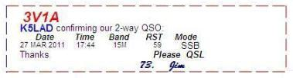
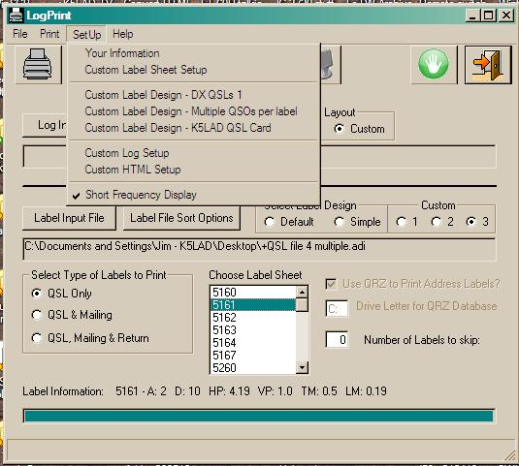
a. Be sure you have filled out “Your Information” and have chosen a printer to use. LogPrint requires some sort of printer to be selected to run, even if it’s to be printed to a PDF file.

b. In the Box labeled "Choose Label Sheet" you can choose the product number for the Avery store-bought labels you planned to use. You can also define your own, referred to as Custom 1, Custom 2, or Custom 3. The Helpfile included with LogPrint fully explains the setup procedures for custom labels complete with pictures.
I was using Avery labels #5161 which is a 1” x 4" smaller label, which is a good label for QSL cards to a station with a single QSO to confirm.
Note: I notice, on my computer, that sometimes when I start the program from the beginning that the "Choose Label Sheet" window has moved from my previous setting to one of the Custom settings on the list. I've not determined exactly why but if your first preview of your labels does NOT look like you expected, perhaps displaying only one label on a page, you might recheck where this window's selection is set.

c. At this point I have a bit of a problem and I’m working on finding a solution. When a logging program, such as Logger32, exports the ADIF file to be used by LogPrint, it does so in the order in which it finds the QSOs to be confirmed which is typically in chronological order or the order in which the contacts were made. This mixes together the entries for both single label and multiple QSO labels with less than desirable results. Using this file, if you had 1” x 4” label stock loaded, the multiple QSO calls would span over two or more labels, even attempting to print a line between labels. If you had 2” x 4” label stock loaded, it would print the multiples OK but would print a single QSO on a large label, which would be wasteful of the paper stock.

Somehow the exported file needs to be subdivided into just those for single labels into one file and all the multiple QSO label entries into a different .adi file. I am currently working on several options to accomplish this including requesting someone to write another standalone program where the user feeds in the whole exported .adi file and receives back two separate files, one for singles and one for multiples.

At this time what I have been doing is to print my multiple QSO labels (option 2) to a PDF file and identifying the single label entries and manually pulling them from the total file and creating a separate file of just singles. This file must be saved with an .adi extension. What is then left in the larger file is just the multiple QSO entries and the order they are in is unimportant since LogPrint will collect and sort the same calls all together before printing.

I’ve also got some other ideas that I’m working on and will update this website article when a better solution becomes available.

c. UPDATE!!! Thanks to Marek – SP7DQR, there is now a solution to the problem described above. Marek has written a clever utility program called QSOs_select that allows a rapid division of an .adi file. The user can create an ADIF file for the paper QSLs they want to send; this is easily done from Logger32 or probably many other logging programs and the ADIF file can be a mixture of calls for a single QSO or multiple QSOs. This primary .adi file can be in any order, i.e., if you have multiple QSOs from the same call they do NOT need to be together in the file; Marek’s program can find them whatever their location and output them together.

You start Marek’s program and it will display a box labeled “Source ADIF file:” and a [Browse] box to let you search for your ADIF file. The program is available at:  <www.whatever the location.html> |  | 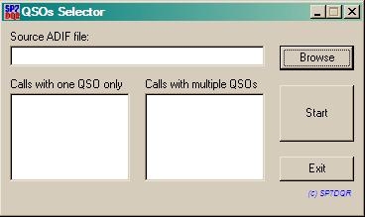

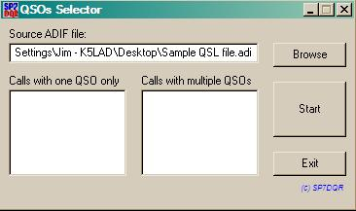 |  | When you click on [Start], the program will find the .adi file and divide its contents into two files for use with LogPrint: one for Calls with one QSO only, and one for Calls with multiple QSOs.

Just as an aside, when I was manually dividing the original .adi file into two files, it took me more than 3 hours. Marek’s program does the same thing in less than 3 seconds, even for a large file. To see more information on the various programs Marek has made available, {see Note #4 below}.

d. Click on the rectangular box labeled [Label Input file] and browse for the .adi file containing the QSOs to be confirmed (see c. above). This file is the one created by your logging program, which will probably be Logger32. If you are using this single QSO setup with the smaller label stock and there are 3 separate QSOs in your file from the same station, it will print 3 separate labels to satisfy the data it finds, i.e. it does not combine multiple QSOs into a single label.
Note: If you have multiple QSOs, i.e., different bands, with the same station, you might want to consider using the second label setup option (Custom Label Design - Multiple QSOs per label) to use only one QSL card and save some postage.

e. Notice that LogPrint allows you to print labels for: QSL Only, QSL & Mailing, or QSL, Mailing & Return. Again, the Helpfile is clear on why you might want to choose one of these options in preference to the others so I would refer you to that document, available under Help under the title bar. I prefer to print my labels for QSL only so under "Select Type of Labels to Print" I just choose "QSL Only" as shown in the example.

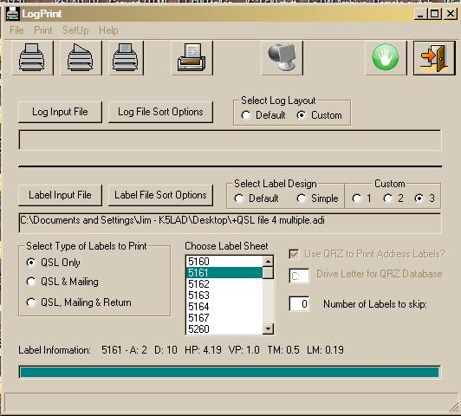

f. Now you can click on SetUp, then click on "Custom Label Design - DX QSLs 1" to display the label design for this label. The setup information is given elsewhere on the website in the article ”LogPrint Multiple Label Suggestions”.
The following picture, on the left, shows the screen that displays when you’ve clicked on
" Custom Label Design - DX QSLs 1" On the right side is the left half of the preview for this setup. Only 10 of the 20 labels per sheet that print are show here to preserve space. Because the box labeled “Show Grid” is checked, you see the dashed lines around each label; the size is in accordance to the dimensions of the label stock you had previously chosen. The button under “Show Grid” will either show [Preview] to show the preview like on the right, or [Refresh] if the preview is already displayed as in the example.
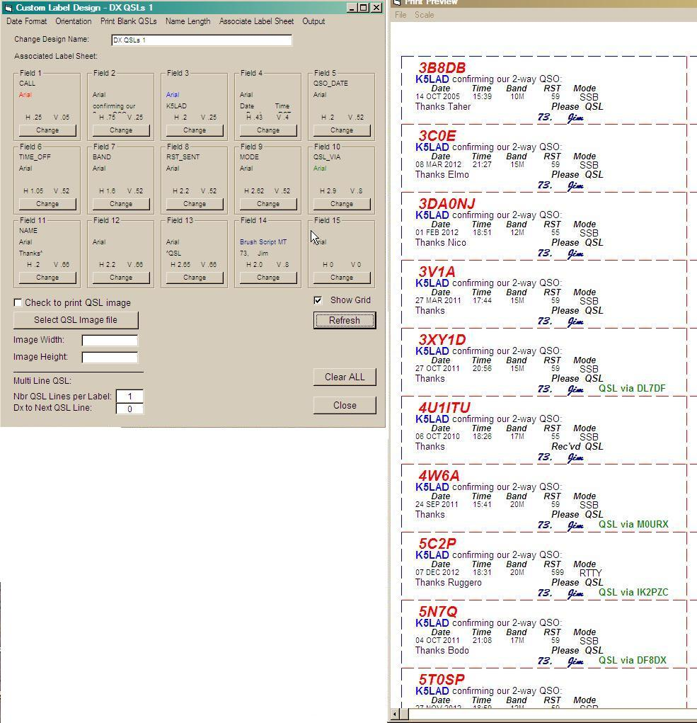

The box to the left of "Check to print QSL image" should not be checked since you're not trying to print a picture on your label. I like to check the "Show Grid" to allow me to see the boundary lines showing each of my labels when I have clicked the Preview box to see what they will look like when printed. The grid here is never actually printed by the printer.

g. When the Custom Label Design is set up like you want it and the preview looks like what you had planned, click on the [Close] box to return to the first screen.

h. Click on "Print" to get the drop-down choices and for this activity, you'll want to click on the 4th choice, "Print QSL Label" The other three choices above it are for printing your log book, either fully or partially.

For #2 ---  Custom Label Design - Multiple QSOs per label |  | 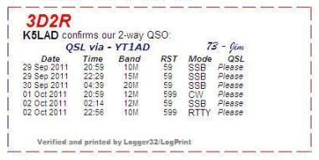

a. Be sure you have filled out “Your Information” and have chosen a printer to use. LogPrint requires some sort of printer to be selected to run, even if it’s to be printed to a PDF file.

b. In the Box labeled "Choose Label Sheet" you can choose the number of Avery
store-bought labels you planned to use or define your own as Custom 1, Custom 2, or Custom 3. The Helpfile included with LogPrint full explains the setup procedures for custom labels complete with pictures.
I was using Avery labels #5163 which is a 2" x 4" larger label, which is good for QSL cards to a station with multiple QSOs to confirm. It will print 10 multiple labels per page and each label can display from 1 to 8 QSOs. When I had my current QSL cards printed by KB3IFH, I had him create a 2” x 4” grid where I can manually insert from 1 to 7 QSO lines, if I’m filling out the card with a pen, or I can paste either sized label over the printed grid. The 2” x 4” multi-QSO labels described in option 2 fits neatly within the grid when I have the label printed on the computer as per this article.
Note: I notice, on my computer, that often when I start the program from the beginning that the "Choose Label Sheet" window has moved from my previous setting to one of the Custom settings on the list. I've not determined exactly why but if your first preview of your labels does NOT look like you expected, perhaps displaying only one label on a page, you might recheck where this window's selection is set.

c. At this point I have a bit of a problem and I’m working on finding a solution. When a logging program, such as Logger32, exports the ADIF file to be used by LogPrint, it does so in the order in which it finds the QSOs to be confirmed which is typically in chronological order or the order in which the contacts were made. This mixes together the entries for both single label and multiple QSO labels with less than desirable results. Using this file, if you had 1” x 4” label stock loaded, the multiple QSO calls would span over two or more labels, even attempting to print a line between labels. If you had 2” x 4” label stock loaded, it would print the multiples OK but would print a single QSO on a large label, which would be wasteful of the paper stock.

Somehow the exported file needs to be subdivided into just those for single labels into one file and all the multiple QSO label entries into a different .adi file. I am currently working on several options to accomplish this including requesting someone to write another standalone program where the user feeds in the whole exported .adi file and receives back two separate files, one for singles and one for multiples.
At this time what I have been doing is printing multiple QSO labels (option 2) to a PDF file and identifying the single label entries and manually pulling them from the total file and creating a separate file of just singles. This file must be saved with an .adi extension. What is then left in the larger file is just the multiple QSO entries and the order they are in is unimportant since LogPrint will collect and sort the same calls all together before printing.

I’ve also got some other ideas that I’m working on and will update this website article when a better solution becomes available.

c. UPDATE!!! Thanks to Marek – SP7DQR, there is now a solution to the problem described above. Marek has written a clever utility program called QSOs_select that allows a rapid division of an .adi file. The user can create an ADIF file for the paper QSLs they want to send; this is easily done from Logger32 or probably many other logging programs and the ADIF file can be a mixture of calls for a single QSO or multiple QSOs. This primary .adi file can be in any order, i.e., if you have multiple QSOs from the same call they do NOT need to be together in the file; Marek’s program can find them whatever their location and output them together.

You start Marek’s program and it will display a box labeled “Source ADIF file:” and a [Browse] box to let you search for your ADIF file. The program is available at:
<www.whatever the location.html>

When you click on [Start], the program will find the .adi file and divide its contents into two files for use with LogPrint: one for Calls with one QSO only, and one for Calls with multiple QSOs.

Just as an aside, when I was manually dividing the original .adi file into two files, it took me more than 3 hours. Marek’s program does the same thing in less than 3 seconds, even for a large file. To see more information on the various programs Marek has made available, {see Note #4 below}.

d. Click on the rectangular box labeled [Label Input file] and browse for the .adi file containing the QSOs to be confirmed (see c. above). If you are using this multiple QSO setup and there are 3 separate QSOs in your file from the same station, they can be mixed in any location in the .adi file. Assuming that you have chosen the Label File Sort Option as CALL for the Primary sort choice, LogPrint will locate all instances of that call throughout the file and assemble them together so they will later print together on a single label.

e. Notice that LogPrint allows you to print labels for: QSL Only, QSL & Mailing, or QSL, Mailing & Return. Again, the Helpfile is clear on why you might want to choose one of these options in preference to the others. I prefer to print my labels for QSL Only so under "Select Type of Labels to Print" I just choose "QSL Only" as shown in the example.

f. Now you can click on SetUp, then click on "Custom Label Design - Multiple QSOs per label" to display the label design for this label. The setup information is given elsewhere on the website in the article ”LogPrint Multiple Label Suggestions”.

The following picture, on the left, shows the screen that displays when you’ve clicked on
"Custom Label Design - Multiple QSOs per label" On the right side is the left half of the preview for this setup. Because the box labeled “Show Grid” is checked, you see the dashed lines around each label; the size is in accordance to the dimensions of the label stock you had previously chosen. The button under “Show Grid” will either show [Preview] to show the preview like on the right, or [Refresh] if the preview is already displayed as in the example.
Note that when you click on Preview, depending on the size of your .adi file and the speed of your computer, it might take quite a while, even several minutes. to display the preview results. During this time, LogPrint is reading all the entries in the .adi file, sorting, then collecting the entries for each separate call sign together.
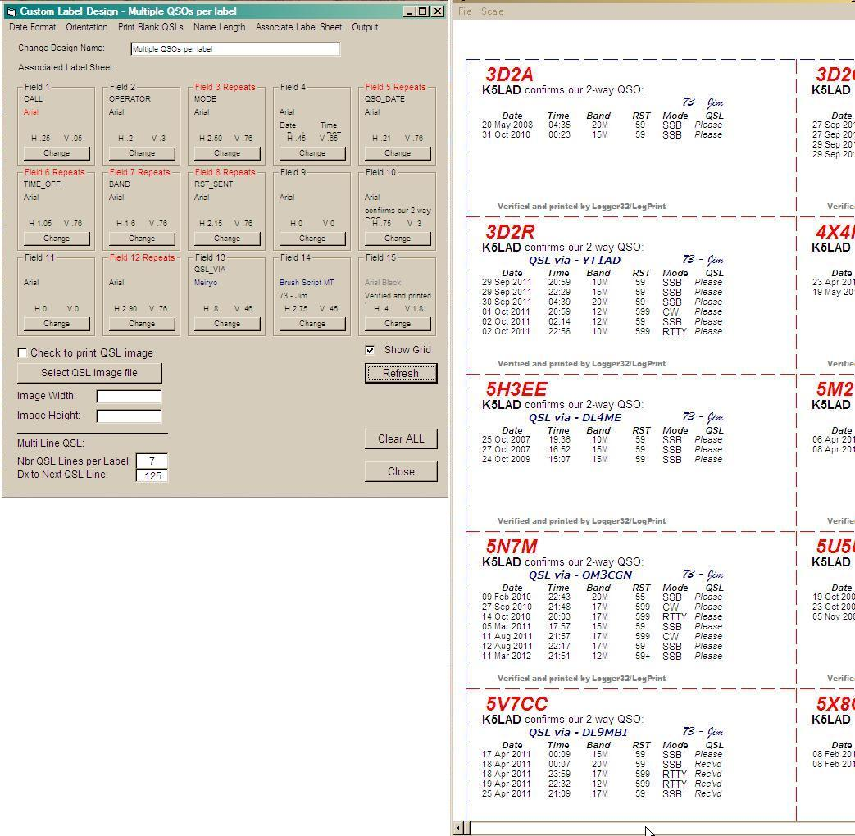

The box to the left of "Check to print QSL image" should not be checked since you're not trying to print a picture on your label. I like to check the "Show Grid" to allow me to see the boundary lines showing each of my labels when I have clicked the Preview box to see what they will look like when printed. The grid here is never actually printed by the printer.

g. When the Custom Label Design is set up like you want it and the preview looks like what you had planned, click on the [Close] box to return to the first screen.

h. Click on "Print" to get the drop-down choices and for this activity, you'll want to click on the 4th choice, "Print QSL Label" The other three choices above it are for printing your log book, either fully or partially.
===============================================================

For #3 --- Custom Label Design - K5LAD QSL Card |  | 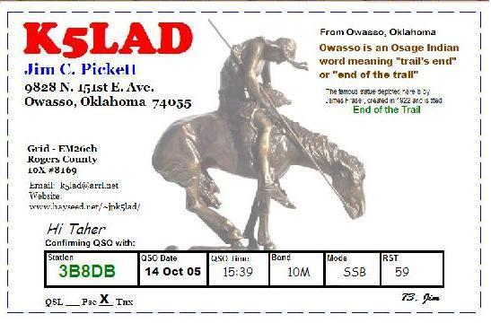

a. Be sure you have filled out “Your Information” and have chosen a printer to use. LogPrint requires some sort of printer to be selected to run, even if it’s to be printed to a PDF file.

b. In the Box labeled "Choose Label Sheet" you can choose Custom 1, Custom 2, or Custom 3 to define the size of the card you will use for your QSK card. For mine, I chose to use Custom 3.
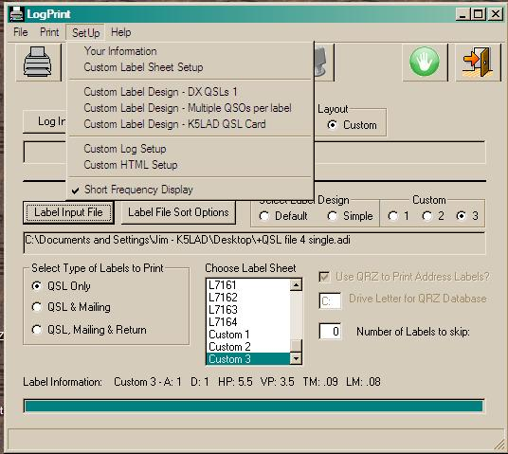

It would be nice to print several QSL cards on a single 8 1/2" x 11" sheet of heavy card stock but, so far, I have been unable to find the secret to this. QSL Cards are typically 3 1/2" x 5 1/2" which means up to 4 cards might be printable on one sheet (if the setup secret was known), and I never did have any luck setting up a QSL card printing in Portrait mode, i.e., printing the 3 1/2" side horizontally and the 5" side vertically. This may be a project for another day or it might not even be a possibility. In the meantime, I will print my cards singly on a single sheet of card stock. {See NOTE 3 below}

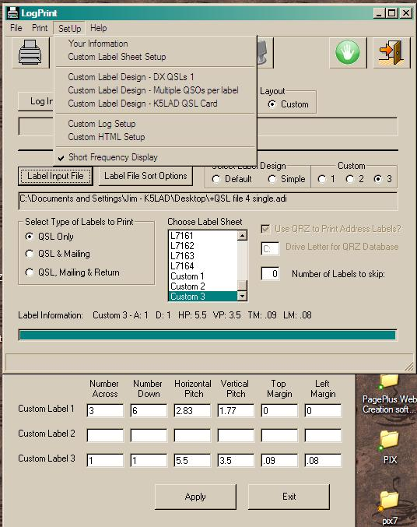
c. Click on the SetUp word at the top of the sub-window and choose "Custom Label Sheet Setup" From the picture you can see how I set up my Custom Label 3 to print a QSL card. When complete, click on [Apply] to write this information to the LogPrint.ini file.

d. Now you can click on SetUp, then click on "Custom Label Design - K5LAD QSL Card" (or whatever name you have designated for this option). Use the QSL card template you created {see NOTE #2}. The print QSL image referred to on the setup sub-window is actually your QSL card template. It includes the picture, if one is included, your call and personal information and any other writing you want printed, and the boxes to fill in the QSO data. Even if you do not have an actual picture on your card template as I have, the QSL card template itself is a picture so be sure to check the box for “Check to print QSL image.” Note that the Image Width (5.5) and Image Height (3.5) is the same size as the finished QSL card since the template picture prints all over the full card dimensions.

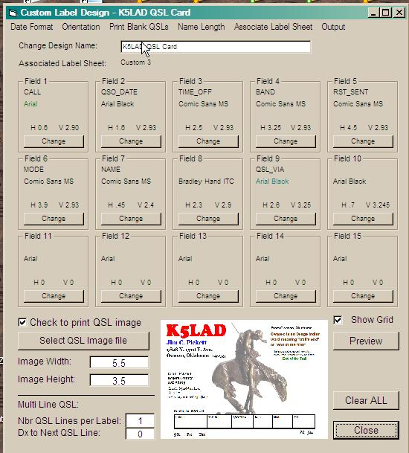

e. The values shown for the 15 fields are the means to pull data from specific ADIF records to print in the required boxes on the card. The setup information is given elsewhere on the website in the article ”LogPrint Multiple Label Suggestions”. I like to check the "Show Grid" to allow me to see the boundary lines of the completed QSL card when I have clicked the [Preview] box to see what it will look like when printed. The grid lines are never actually printed by the printer.
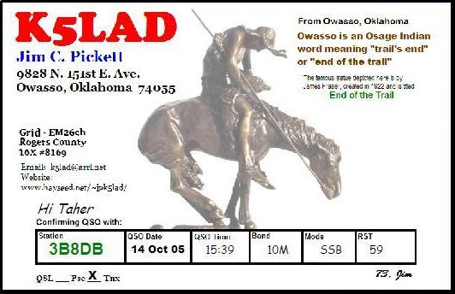
f. When QSL card is set up like you want it and the Preview looks like what you had planned, click on the [Close] box to return to the first screen.

g. Click on "Print" to get the drop-down choices and for this activity; you'll want to click on the 4th choice, "Print QSL Label" even though you might not consider the card as a label. The label designation is still the closest to the QSL card printing, according to LogPrint's options. The other three choices above it are for printing your logbook, either fully or partially.

h. QSL card printing using this method is slow and requires close attention to the task but printing this way may be used primarily for creating just a few cards at a time. If you desire to print a fairly large number of cards at one time, the options for printing single or multiple QSO labels might be preferable.

===============================================================
===============================================================

NOTES:
Note #1 – If you do not have a printer available or you don’t want to use up your label stock or heavy card stock for QSL, consider a program which announces itself like a printer but prints, instead, to a PDF file, readable by Adobe Reader XI (available free at
http://get.adobe.com/reader/?promoid=JZEFU)
Install a program called PDF995 to have this available. You can find it at http://www.pdf995.com/. It is a free program but the non-registered version has quite a few advertisements as it runs. For a small fee (currently $9.95) you can get a key to eliminate the sponsored advertisements.

Note #2 - The template for your QSL card can be as simple or as complex as you like it. There are free programs available on the Internet that allow you to add your own information while it arranges it in the proper places for you. I would recommend that you spend an hour or two looking over QSL cards shown on the Internet or if you have already received QSL cards from others, look them over to get ideas of what you would like. It is easier to create your own template if you spend some time seeing how others have made their cards, either created by themselves or by commercial QSL printers.

For my template, I used the simple Microsoft Paint program that has been included in Windows packages for many years, perhaps from back to the first Windows OS package delivered. It is simple to use, freely available, and provides a good finished product. I am far from a creative artist but I think mine looks pretty nice.

The boxes for data can be place at any location on the card face. It requires some experimentation with setup values but you can instruct LogPrint to insert the proper data from your .adi file into the proper boxes, regardless of where they appear on the card.

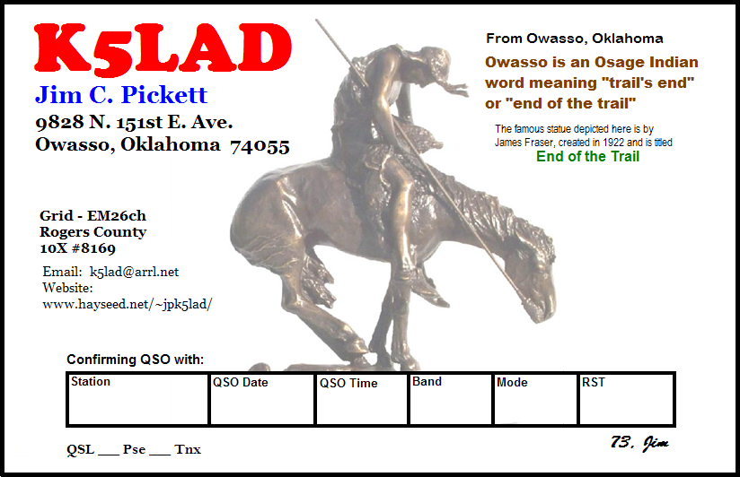

Note: You can also print copies of your QSL card template and create blank cards to manually fill in the boxes for a single, quickly required card. This is done by displaying the QSL card setup screen (option 3 on my examples) and choosing the selection message under the title bar that says “Print Blank QSLs”. More detailed instructions are given for this activity in the Helpfile.

Note #3 - When I print a single card on a single piece of heavy white or colored card stock, I use a metal-edged ruler and an Xacto knife to measure, then cut out the 3.5" x 5.5" card from the 8.5" x 11" sheet. Once the partial sheet is trimmed to an 8.5” x 7.5" size (because you have already used up a part of the sheet), it can be used to create one and perhaps two more cards by carefully hand-feeding the remainder into the printer. It's not quite as good as being able to print 4 QSL cards per sheet in Portrait mode, but I find it satisfactory for my use.

Note #4 – Visit Marek’s website to find some really nice utility programs he has written and made available at no cost. Some of his programs are specifically to work with a program such as LoTW to Logger32 Credits, specific to Logger32. His program Log Recoverer can take a part of the Logger32 logbook file and recreate a fully usable logbook file for Logger 32. For a user of Logger32 who failed to keep a current backup of their logbook, and discovered their current program in a crashed condition, Marek’s Log Recoverer program can often save them from a bad loss. Take some time to look over his website and study the list of his free programs available for download. You’ll, no doubt, be glad you did.

If you would like to see or have a copy of the LogPrint.ini used for this article click here to download. It has all the setup information for:
Printing single QSO labels
Printing multiple QSOs labels
Printing full QSL card with QSO data

===============================================================
===============================================================

ERROR Messages in LogPrint v.3.1.2
-----------------------------------------------------------------------------------------------------------

ERROR 1 - Runtime 383 Error
When Field9Condition=|notEqual|Rcv'd|Please|
I got a Runtime Error 383. I deleted the "not" to just leave "Equal" and still got the error. I deleted the "Rcv'd" and "Please" and the error went away. Note: the error can occur on any of the 15 fields but in this case it was in the data I had in Field 9 of a label setup.

On Field9Condition=|notEqual|yes|no| --- I got the error
On Field9Condition=|notEqual||| --- I got the error
On Field9Condition=|Equal||| --- I did NOT get the error

Conclusion - Runtime 383 Error is caused by an inappropriate setting in the Field#Condition setting.

NOTE the correct entry shown below:
Field9Condition=|Equal|||

Another observation on this error:
When a Field is removed from usage, it is vital that it be removed correctly and thoroughly. You cannot just remove the vertical and horizontal positions, the
ADIF fields to choose for decisions and the ADIF field information to print ---
you MUST click on the button labeled [Clear ALL] which returns the
"Fields#Condition" entry to that shown above, i.e., Field9Condition=|Equal|||

Anything else will bring up the "Run-time error 383 -- Text property is
read-only" error message.

===============================================================
ERROR 2 - Runtime 481 Error - Invalid picture

This error occurs when the Setup routine expects to find a picture to use in a QSL or SWL card print but the picture cannot be found

Conclusion - a missing BMP picture file causes a Runtime 481 Error. Note also that LogPrint asks you to load a .bmp picture file but a .jpg picture file will work. When it requests [Select QSL image file] the window shows “Files of type;” and fills in the box with “BMP Files (*.bmp)”. To load a .jpg file, change the “BMP Files (*.bmp)” to All Files (*.*)
BMP {bitmap} files are generally several times larger than JPG files in number of bytes. These larger files should be better resolution over the JPG but my old non-artist eye cannot see any difference.

===============================================================

ERROR 3 - QSL via printing on wrong label
My QSL via - (call) entry kept printing on the wrong label, (it printed below on the next sequence of labels) particularly when the printing location was near the bottom of the label (above the "Verified and Printed by Logger32/LogPrint" line). After much work and changes, I determined that it worked correctly when called upon to print above the logbook entries closer to the top of the label.

Conclusion - I never did determine why this happened but moving the print location for the QSL via - to a higher spot on the label cured the problem.

===============================================================
ERROR 4 - Preview and/or printout only shows a single label on the page instead of the full page of labels as expected.

I noted previously in the article, that occasionally I’ve discovered, on my computer, that sometimes when I start the program from the beginning that the "Choose Label Sheet" window has moved from my previous setting to one of the Custom settings lines on the list. An example might be: you originally had the "Choose Label Sheet" highlighted on #5161 because you wanted to print 20 – 1” x 4” labels per sheet but when you look at the preview or the printed copy, only one label appears on that page or some strange configuration appears other than what you wanted.
Go back and look at your "Choose Label Sheet" and make sure it is still on the highlighted line - #5161.

Conclusion - The solution is to reset the "Choose Label Sheet" to what you need.

ERROR 5 - Runtime 380 Error - Invalid property value

I ran across a note with a screen print with this error #380. I’m trying to find more information about it but I currently don’t have a solution. I wanted to mention it here since others might run across the error and see that they’re not alone.
When I discover a solution to this one, I’ll add it to the website.

===============================================================
ERROR 6 - Printing one page of labels that span several pages. Incorrect paging of printed pages

One of the problems I ran into came a couple of years after I had successfully used the setup described in the original website article. After making the changes for the improved Multiple QSOs Labels, when I tried to print them on the label stock or to the PDF file I got disastrous results.

When printing either single QSO {option #1} or multiple QSO labels on Avery #5163 (2" x 4") label stock {option #2}, it would print the first 8 labels per page correctly (or 18 labels with option 1). The picture below shows what should have been the last 4 labels at the bottom of the page where 10 labels were to be printed per page. The bottom two labels of every full page was like this.

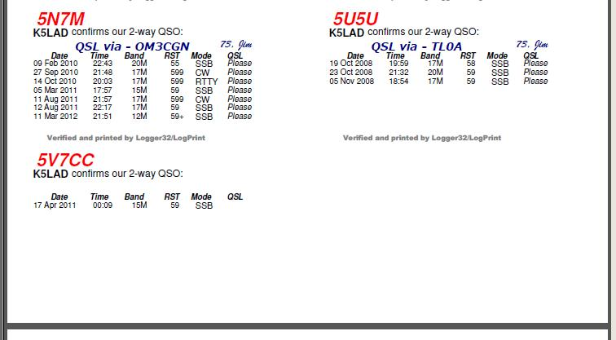

The label at #9 spot (lower left of page) would print most of the top of the label and most of the first QSO entry but the "Please" or "Rec'd" would be at the bottom of the next sheet.

This shows what was printed on the second sheet. All above this printed information was completely blank.
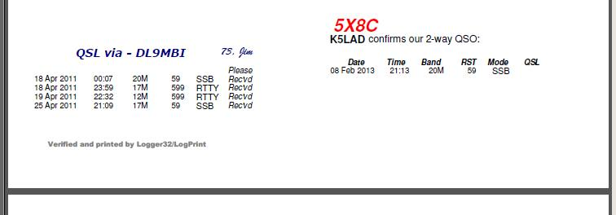

The label in #10 spot (lower right of page) would print none of the label but would print (as with #9 above) most of the top of the tenth label up to the "Please" or "Rec'd" and that would skip down to a third page, just as the rest of #9 was printed at the bottom of the second page.

All that was printed on the third sheet was the few lines below. All above this printed information was completely blank.
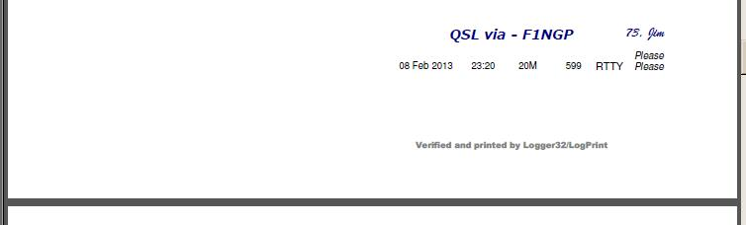

The next sheet of labels printed was back like the first sheet above with 8 (or 18) full labels printing correctly and the bottom two labels spread over the next two sheets.

I struggled for several days trying to vary the values in several of the setup boxes and I really suspected that something in the setup feature which prints the "Please" or "Rec'd" for QSL was incorrect but I just could not see it.

I finally discovered that the problem was in the Field 11 box which had the following data left over from my previous setup. I would have sworn that I removed all that data when I modified my new setup but obviously I had not. The Field 11 box, which should have been empty of data, instead had the following still in it:
------------------------------------------------------------------------------------
IF - QSL_RCVD
IS - Equal
TO - Y
THEN - Rec'vd^
ELSE - Please
Horizontal - 2.2 Vertical - 3.3
Current font is Arial at 10 pts.
------------------------------------------------------------------------------------
Once I clicked on [Clear ALL], all the values were removed and the skipping pages and labels problem was gone. Something quite small can cause you major problems. I guess you could say that the moral to this story is, Don’t overlook the obvious.

Conclusion:
As you work with LogPrint and become more comfortable with it, my recommendation to you would be, once you have a version working correctly and printing, at least partially like you want it to print, SAVE a copy of that working LogPrint.ini file in a separate folder and write yourself a text message that “this one is working.” When LogPrint crashes with an error message it will often shut down completely and it is hard, if not nearly impossible, to get past the error message to correct the error. You must do your correcting within the .ini file to get past that error. Being able to go back to a known working LogPrint.ini file will keep the frustration factor down to a MUCH lower level and, perhaps help extend your life for several days longer.

Also worth noting is, if you locate a new piece of information that allows LogPrint to produce something you especially wanted it to do, it is possible to leave yourself notes within the .ini file. To do this, precede any line that is a note to you but not to the program with a semi-colon (;).

; Field3Condition=|Equal||| this line made LogPrint go bonkers and spit
; printer paper over the floor (No, no this is not a true error, just an example of a REMark)

Note that the semi-colon is only required at the beginning of a line. It is saying, “disregard anything you see to the right of that semi-colon on this line.” If the REMark line is longer than a single line, the line can be split but each line to be ignored must start with a semi-colon.

Also, if you’re having a problem with some area and you suspect a line in the .ini file is causing you the problem, you can REM that line (or several lines) out by placing a semi-colon in front of the suspect line. LogPrint will then not read or execute the line but you will be able to find the EXACT wording and location to put it back, just by locating and removing the semi-colon/s.

There have been times I have worked with the LogPrint program and been able to create a label or card looking exactly as I had pictured it; the operation went as smoothly as silk. There are other times when I have spent many hours fighting with a misprinting problem, or even worse, with an error message that was unclear and might as well have been written in hieroglyphics. I hope that some of the ideas given in this new article, and particularly a clearer description of the error messages, will allow you to create some very nice pieces of work.

73, Jim – K5LAD
Jim’s notes to Jim:

This version of LogPrint seems to be the best one available.
The attached LogPrint.ini file is correct as of March 19, 2013 to print the following documents.

The Custom Label #3 is my EOT single K5LAD QSL card to be printed on the Kodak color inkjet printer. Everything is lining up correctly, no errors in running or printing and
the only problem now is to get the printer to accept and print a single small piece of card stock. Currently it will not print a small piece as it reports the wrong size paper in the tray.

NOTE: It IS possible to print a piece of card stock by feeding it in, short end first. This requires setting the Orientation option in the Setup |Custom Label Design - K5LAD QSL Card | Orientation Setup screen from Portrait to Landscape. I'm still working on the problem of getting the printer to accept the single piece of small paper.

JCP - October 3, 2012
=============================================================
As of May 31, 2011:

I cleaned up the many different versions of LogPrint files and attempted to get them together. Those are all currently in a folder titled:
K5LAD Logprint Total Collection 053111
and inner folder titled:
+MAIN+Logprint v3.1 as of 053111B & 040611A

The information about which Avery label stock to use in at the beginning of the Logprint.ini file
=============================================================
K5LAD Label Fixes

1. Multi-QSO label - Show MODE by line
2. Multi-QSO label - Show RX or PSE QSL by line
3. All QSO labels - shorten QSL to ?????
4. Single-QSO label - Add "QSL to" for QSL Manager
5.
=============================================================
http://www.hayseed.net/~jpk5lad/LogPrint%20Labels/LogPrint.htm

