Policing the Police
By Jim Pickett – K5LAD

Ham Radio activities are often FUN but seldom could be called “FUNNY” however a recent afternoon in November showed me that some really funny things can come up on the ham bands. I’ve previously mentioned, in earlier articles, about the ‘UP Police’, the folks on the ham bands who cruise the DX activities on the HF bands and verbally chastise the hams who transmit on the same frequency of a DX station who has announced they are listening up the band, often from 5 to 15 kHz from his transmitting frequency. The transmitting error may be caused by accidentally failing to properly set up a transceiver’s split feature or often by their failure to listen to the DX station’s often reoccurring announcement that they are listening up the band. It can also be a failure of the application of good old common sense, which should tell the calling station that almost every DX station operates split and they should seldom ever transmit on the same frequency as the DX station.

Nevertheless, that should not give the Up Police the right to be rude, to a station who makes an error. Only humans [thus far] have been issued ham licenses the world over so the Up Police are sure to be human and all humans make mistakes. Are they, somehow, perfect? I believe it’s OK to let an offender know the DX station is working split but to call them offensive names is beyond good Amateur Operating Practices and puts a bad light on the amateur ranks in particular.

The funny activity I mentioned was near the end of November, 2012, while a DXpedition was operating from a rare and uninhabited geographical location in the Atlantic Ocean called Saint Peter and Paul Rocks. This station was signing PT0S and it was a spot that hasn’t been occupied, or opened for DX operation, for several years so the pileups were fierce. When such a high percentage of DX enthusiasts all need the same DX stations, the pileups become pileons. Typically, during a DXpedition from a regular needed site, the first several days belong to the “Big Guns” with high dollar equipment and monstrous, flying-bird killing towers and antennas. Hams with lesser equipment and antennas usually must wait until the “Big Guns” have had their chance and then they’re able to make contacts with the exotic DX station. When EVERYBODY needs a station, the lines get longer and the wait gets larger. A DXpedition always is planned and organized for a limited number of days so it is possible for the operation to end before everyone has an opportunity to that much anticipated QSO.

Since I’m running an Elecraft K3 transceiver with the matching P3 panadapter, I’m able to not only see pileups but I can save pictures from the P3 to show how the hundreds of stations were distributed across the various frequencies where the DX station was listening. The pictures shown in the article were created with this equipment.

In the picture below, the green vertical band shows where the DX station was transmitting and is the setting for my transceiver’s VFO A that is controlling the primary receiver. The width of the band is determined by the width of the roofing filter along with the setting of the DSP adjustment. In the case here, the receiver’s VFO A was sitting on 21.295.00 kHz as displayed by the number displayed at the top middle of the panadapter’s screen. Since I was using upper side band (USB) for 15 meters, the green bar shows a darker green line at the left side and the audio frequencies up to nearly 3000 Hz are within the green bar; low audio frequencies on the left and higher audio frequencies to the middle and right.

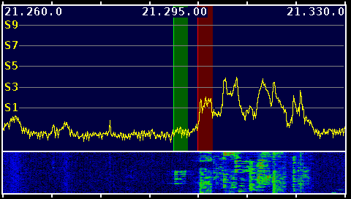 |  | up for that). When I’m set up this way I can pipe the VFO A reception into the left head-phone element and VFO B reception into the right. If, however, I am working a DX station who is working split, as most of them do, I place the transceiver into the SPLIT mode and the purple vertical bar changes to a red color. It’s very handy when, in the heat of battle, I can see by the bar’s color that I’m working split and will not become the target of the dreaded “Up Police.”
The red bar either shows VFO B’s setting or the filter width of the 2nd internal receiver. In my case I do have the 2nd receiver. Usually the VFO B vertical bar is a purple color which would means I am both receiving and transmitting on VFO A but I can listen to other frequencies (and actually another band if I had it set

The DX station had announced that he was listening “5 to 30 kHz up” which is a much wider window than is typically used. Some “waiting in the wings” operators were critical of his announcement since it was taking up so much spectrum space on the band, but his reasoning was to spread out the tremendous number of people calling him. In the picture above, the left edge of the red bar was at about the beginning of the “5 kHz up” mark and since the panadapter’s scan was set at 70 kHz (shown by the frequencies 21.260.0 and 21.330.0) so the whole right-hand side was a graphic display of stations calling him.
NOTE: The S1-S9 numbers on the left-hand scale are not pertinent since I had not adjusted for that scale accuracy at this time.

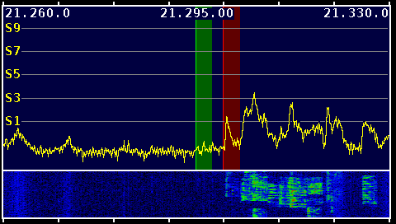

There are several pictures displayed here and all show, basically, the same frequency window over a period of several minutes. In each of the pictures, I had it grab the picture when numerous hams, from all over the world, were calling PT0S, all at the same time. I did not grab any pictures during the time the DX station was transmitting so you don’t see an actual signal within the green bar, only the “grass” which represented random band noise.

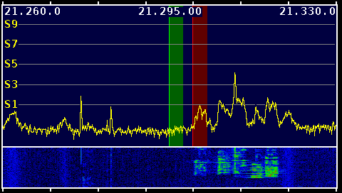

The actual funny part of the activity, and what prompted this article, was when another DX station, on another DXpedition, came on the same band but just down frequency from the PT0S operation. The station was V84SMD in the country of Brunei in Southeast Asia and was also a rare spot, much desired by DXers around the world. Either the Brunei group was unaware of the group at St. Peter and St. Paul Rocks or they thought they would be far enough away from them. My guess was the former.

V84SMD began to transmit on 21.290 kHz. and to instruct their callers that they were listening “5 to 10 up.” The pictures shown above were made after the following hilarious debacle. I wish I would have captured some pictures of the actual debacle but I was both laughing at what was happening and feeling ashamed to hear the bad activities of what transpired. I have taken one of these other pictures and tried to identify, graphically, what was happening by adding the following “semi-artistic” additions.
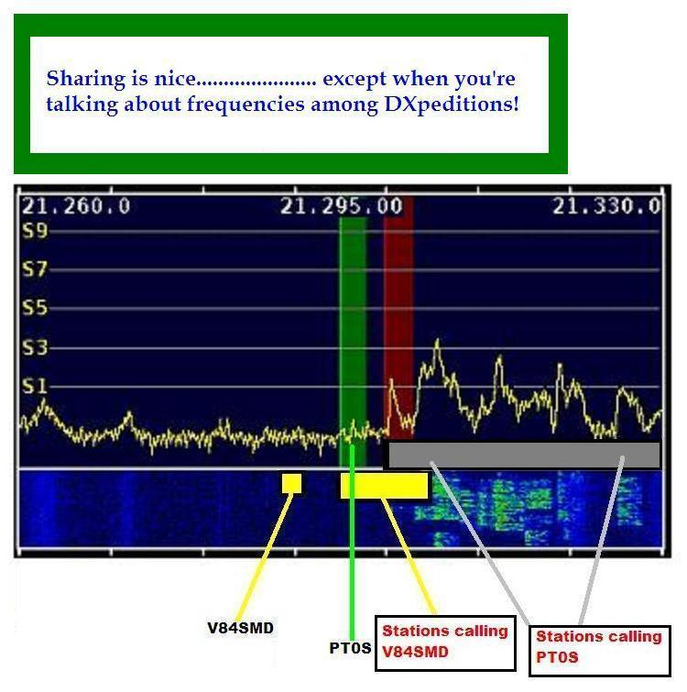
The St. Peter & Paul Rocks station (PT0S) was transmitting at 21.295 MHz shown with the green line pointing to the green vertical bar. He announced that he was listening “5 to 30 kHz up,” shown here as the large gray rectangle. The Brunei station (V84SMD) was transmitting at 21.290 MHz, shown above as the small yellow square. He said he was listening “5 to 10 kHz up”, shown here by the larger yellow rectangle. You can see, from the picture, that there was an overlapping of the frequencies of the two DX stations and their callers. Every time someone called V84SMD 5 kHz up, they were transmitting on PT0S’s transmit frequency.

The UP Police went ballistic and cut loose with some of the most foul language and insults that have been perpetrated on the amateur bands. “Hey you moron, he’s not here……. He’s listening up the band!” “You stupid idiot, don’t you know how to operate your radio; he’s not listening here!” I’ve left out all of the expletive adjectives used but I think you understand.

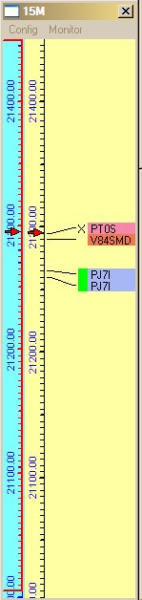 |  | The picture on the left shows the 15 meter band Bandscope taken from Logger32 at this time. It shows the entries to the DX cluster I was watching and shows (at the red arrow) where my VFO A was set to listen to PT0S on St. Peter & Paul Rocks. Just below PT0S, and just lower in frequency, was V84SMD.  The trouble was, these guys calling V84SMD could not even hear all the vitriolic insults being leveled at them because they were actually listening, not on 21295 kHz but instead, down on 21290 kHz.  This went on for at least 10 minutes and the Up Police got madder and madder.  NOTE: I remember my 2nd grade teacher telling us that “dogs get mad but people get angry” and I always remembered that useful piece of information. However, I feel that I must say, that what I heard that day tells me that those fine, upstanding citizens of the Voluntary Up Police Force were not angry……… they were MAD!  It would not surprise me to hear that on that day, on 15 meters, our “fraternity” lost several members to severe heart attacks, strokes, and blown personal head gaskets.

Finally, after about 10 minutes or so, someone noted on the DX Cluster that another DXpedition was down frequency from PT0S and they were calling V84SMD on his advertised listening frequency and NOT violating the sacred ground controlled by the self-appointed Up Police.

For what it’s worth, I did work PT0S on St. Peter & Paul Rocks and did not work V84SMD at Brunei. I wish I could report that as the band closed out and some of the participants had a chance to reflect on their shameful actions and that a group formed and the active violators civilly and quietly discussed their actions and apologized to all the listeners for their temporary animalistic and deplorable activity. That didn’t happen, however, and I’m forced to think they left their hamshacks to tell all of their family what wonderful followers of the DX Code of Ethics they had been.

All in all, was it funny? Yes, I thought so.

Was it also sad to see supposedly intelligent individuals acting like this” Absolutely

Hiram Percy Maxim …………….. where are you when we need you so badly now? Where are the Wouff-Hong and the Rettysnitch? (Google them if you’re unfamiliar with these two amateur radio-related instruments)

