Interesting Terminology on a Classic Transceiver

Throughout the annals of ham radio history there have been hundreds of different pieces of equipment to bring joy, and sometime pain, to the licensed ham radio operator. Among those hundreds of pieces there have been a select fewer and smaller selection of items that could be referred to as classics. Those classics have lingered longer and maintained their popularity for much longer periods of time. The classic piece tends to hold its value for much longer, often many years, among the ham population.

One of those classic pieces was the Kenwood TS-520 and it’s similarly numbered family followers including the TS-520S, TS-520SE, TS-530, and TS-530SP. Kenwood had produced other transceivers but when the first TS-520 came out, it was a fairly revolutionary concept since it was primarily all solid-state with the receiver fully transistorized and only 3 tubes in the transmitter (the driver tube [12BY7] and a pair of final tubes [S2001 – Japanese version of the 6146]). Incidentally, the first 520 was introduced to hams in the United States prior to the time that the Japanese Trio-Kenwood company had set up a sales and service headquarters in the US which was sometime in the early 70s. Prior to their US facility, the Kenwood line was imported by the well-known Henry Radio, Inc., in Los Angeles, Calif. I was one of the first Kenwood dealers in the US at Derrick Electronics in Broken Arrow, and all my original Kenwood dealings were with the folks at Henry Radio.

There were numerous reasons that set apart the TS-520 transceiver and guaranteed their popularity: hybrid construction with few vacuum tubes, portability, ability to add a CW crystal filter, low cost, they sounded good on both receive and transmit, they looked good and worked well. The first model even had a module included that allowed operation on 12 volts DC in addition to the built in 117 volt AC power supply. There were a number of hams who ran the TS-520 as a mobile rig although by comparison in size with many of the mobile radios today, it was a mighty big mobile rig.

One of the most interesting “features” of the TS-520 was an addition to allow modifying the audio in the transmitter section to make the transmitted signal more “penetrating.” At that time there were several, usually external, devices, which allowed modifying the transmitted audio to provide more talk power and make your signal more understandable by DX stations. There were audio compressor/expanders to raise the level of audio. There were more expensive RF and audio compressors that did the same type of task. Now a days, almost every commercial HF transceiver has a built in audio compressor but back in the 70s, this was not the case.

The TS-520, however, did have a built-in feature that changed the characteristics of the audio in the speech amplifier. As I recall, and I did not go back and search the older schematics, turning the “feature” on changed only a few components and I’m thinking it might have been just a single resistor or two. Kenwood made the “feature” available for the user to be able to easily and quickly turn it on or off from the front panel by adding a push/pull switch on the microphone gain control potentiometer. Oddly enough, for some reason, Kenwood labeled the switch “DX pull on” which was actually their way of saying, “If you want to work DX, pull on this control knob to turn it on.”

I recently ran across a TS-520 being sold on ebay and it reminded me of those good ole’ days when the 520 was so popular. The “DX PULL ON” is located on the right side of the front panel and is the gray knob just below the PLATE tuning capacitor. The knob below the PLATE knob had three functions: the larger outer knob (MIC) provided the user with the ability to raise and lower the gain in the microphone audio circuit, the smaller inner knob was use to insert carrier (CAR) for tuning, and the marking above the MIC - CAR is the DX PULL ON, executed by pulling on the smaller inner knob.
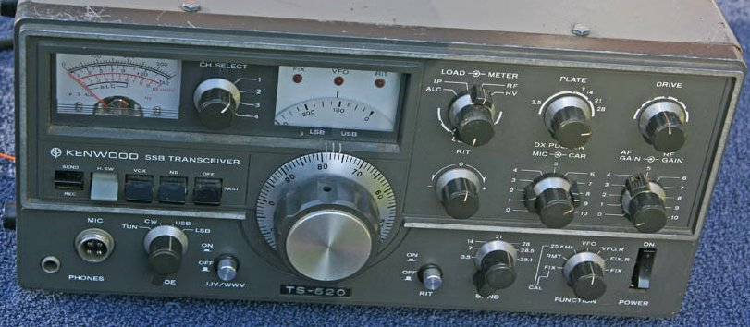

The funny thing was, this panel message became the way everybody described the actual operation. For instance, any time a ham used the control they would say something like, “Tell me how I sound when I turn on the DX PULL ON,” or, “I’m hearing some QRM on your signal on your 520. Why don’t you turn on the DX PULL ON?” That is almost exclusively the way this control was referred to, in person and on the air.

Later models in the 520-530 changed the markings to call it a compressor but the die was cast with the first TS-520 and, for many years both during the time they were sold and afterward, hams referred to that ‘feature’ as the “DX PULL ON.” Even today, if I’m not careful and I’m talking to someone about their TS-520 or one in that family, I catch myself calling it the term from back in the ‘Good Ole’ Days.’

