If the Words Get Stuck In Your Throat……………….

By Jim Pickett – K5LAD

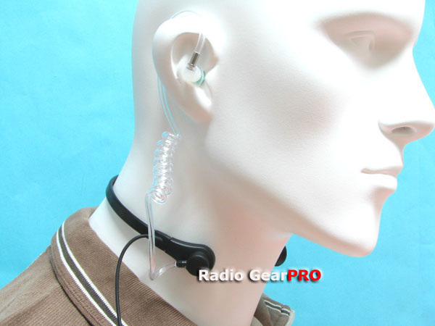 |  | I recently was looking over some pages on Ebay and I came upon an entry for a throat mike. This particular mike was for use with the past and current models of the Yaesu dual-band talkies but it reminded me of a long time ago experience I had with a throat mike.

Having been born during the World War II years, I didn’t see the use of a lot of these military items “in person” but instead, I saw many of the old war movies and saw the pieces in action on the screen. As a youngster, I acted out many of the battles I’d seen in those movies and thought I knew quite a bit about what actually happened.

During my teen years, when I began to develop an interest in radio and electronics, I loved to visit the “Army-Navy Surplus” stores and see the wonderful items they offered for sale, particular those with a radio tie-in. These items were often quite inexpensive but they might as well have been a million dollars since I had no money to spend. On the few times I did have a bit of money to spend, I remember buying some really nice things including a brand new brass telegraph key that I got to unpack from the wax-coated canvas bag in which it had been sealed by the manufacturer. That key may have been manufactured in some small plant in a small American city and waited patiently in a warehouse before it was able to take its place on foreign shores during the war effort. Perhaps its time never came before the war ended and it became just another item to sell to the military surplus sales stores.

This was not the J-38 key that was mounted on a Bakelite board but was the same size and style of the J-38. Since it was brand new, it gleamed its brassy gold color, just waiting for someone to hook it to a transmitter to send messages and greetings around the world. I used that key for many years and wish I still had it, however, it somehow got away from me as life advanced around me and it got lost among a hundred other treasures. I do remember that I paid 98 cents for that brand new key. Gosh, I wish I had possessed the insight to buy a case of these keys………………. but then, I imagine that I was lucky to afford even the one.

Another item I bought was an aircraft throat mike. Seems like it was also in the 98 to 99 cent price range and it was the first microphone I ever owned. I knew little to nothing about audio and microphones but the idea of a “throat mike” was fascinating to a young enthusiast like me.

A throat mike was somewhat different than a regular microphone as it didn’t have holes for sound to enter and become electrical signals, but consisted of two black plastic buttons about three-quarters of an inch in diameter. This was mounted on a cloth strap, which clamped around the neck and held the two elements (buttons) in a location approximately on either side of the Adam’s apple. I’m not quite sure what female pilots used. The throat mike was typically used by military folks in airplanes, i.e., pilots, gunners, navigators, etc. It solved two major problems with communications within the airplane and that is: the noise was often quite extreme but would not be picked up with this type of mike, plus it solved the problem of a user having to locate their hand mike, in the heat of battle, since their hands were often filled to capacity with the activities of their current task. The throat mike was always there and ready to be used.

Throat microphones were of the carbon variety, just as were the microphones used in home telephones for many years. Carbon mikes are fairly rugged, and although they did not typically provide as good audio fidelity as other types, were inexpensive to manufacture, provided usable audio and were, again, quiet sturdy and rugged in their construction. A carbon mike did require that a small voltage be applied to the carbon granules inside. The circular carbon mike buttons, which pressed against the neck, would pick up vibrations in the throat and convert them to usable audio for the radio and plane’s intercom system. In particular, the audio was not as good as a hand microphone but, under the circumstances, it was there and was usable.

The idea of having a microphone as used by World War II pilots was a delight to me as a young teen radio “nut.” I had no transmitter to hook it to, I didn’t really know how to hook it up to get some sound from the vibrations in my throat but I remember how badly I wanted one of those throat mikes.

Finally I was able to earn some extra money and the next time I was in Tulsa and could get by the Army-Navy Surplus store, I bought one of these mikes. Just as with the key mentioned previously, it was brand new and still in the waxy-coated canvas bag. I wore that throat mike around for several days with all sorts of dreams of how I could hook it up to something.

As with many of the stories I’ve shared, I’ve usually had to admit that I don’t remember whatever happened to a particular item I acquired during my early ham years. This, however, is not the case with the throat mike as I remember exactly its final hours.

I had read about the fact that a carbon mike needed a voltage to make it work and I knew also that a speaker could reproduce audio voltages. Why not place the carbon throat mike in series with an old surplus speaker, with a voltage for the carbon element and see if I could hear my voice coming from the speaker? I don’t remember exactly what I used for the voltage source but I do know that I was smart enough NOT to use the AC line voltage. It was probably a battery or maybe a series of batteries but I put the throat mike on and proceeded to hook up the “circuit.” I do remember, and all too well, that the voltage used was high enough to exceed the needs of the microphone and while waiting for the reproduced sound, the only sound I heard were my screams when the two button elements got so hot that they began to burn my neck.

I tore the mike’s connecting strap off my neck and proceeded to treat my near burns. Disconnecting the power from the “circuit” was the least thing from my mind at that time and by the time I returned to the audio experiment, the element buttons had taken on a different shape than from their original. I was glad I had survived the ordeal with little more than two red welts on the front of my neck and a military surplus throat mike that was melted enough so that it was no longer usable.

As enjoyable as the thoughts of that throat mike experience had previously been, I threw away the pieces and thanked my lucky stars that I had not gotten off in worse shape. Now, more than fifty years later, I’ve never had the least desire to own another throat microphone for any of my ham equipment……………… and I never will.

