Antennas Seem to Work Better When They’re Higher in the Air

Various antenna launcher tricks

By Jim Pickett – K5LAD

One of the activities enthusiastically practiced by hams, both young and old, novice and veteran; is the installation of one or more wire antennas. The verbal expression from the success of these ventures can run the gamut from "Hey, I got it the first time" to "Ouch...ouch .......ouch......!!" It can be anywhere from highly rewarding to downright painful.

Often the original string over the tree is a light gauge of string or monofilament fishing line and could not be expected to support a wire antenna that places extreme pull on the support. Obviously, once the first lightweight cable is over the desired place on the tree it can be used to haul up a heavier cord or rope to act as the final antenna support. If a very heavy rope is to be the ultimate support, it might require several successive pull-overs, with each line being used to pull up an even heavier version.

Hams have always had numerous and varied tactics for getting the end of an antenna support rope up into a tree. Those with strong arms might simple try the, ‘baseball pitcher approach,’ i.e., tie a rope around a rock and chunk it up as high as possible, hoping to clear the top of the tree and then hoping that the thrown end makes it back down, at least close enough to the ground for them to reach. Perhaps they might bring out the old fishing gear and attempt a high-altitude cast from ground, over the tree, and (hopefully) back to ground.

Some have tried to enlist the aid of centrifugal (actually centripetal) force in what might be referred to as the ‘David and Goliath Effect.’ This is accomplished by swinging a weight, attached to some type of cord, around in a wide circle and letting go at just the right time, hoping to send the weight high above the top of the tree and still have the weight bring the end of the rope down to within their reach. Who among us, who have tried this method, have not gotten the weighted end wedged only partway up the tree and had to pull and jerk on the rope to retrieve it for another attempt? And who, having used this method did not finally extract the weight, only to have it break free and return to you and a high rate of speed and either conk you in the face or some other body part or, at least scare the bejebers out of you when it "just missed?" This is not, however, the origin of the word “jerk” as used as a personal attribute term but there are some similarities in the terms.

Another idea for an antenna launcher over a high obstacle might be an attempt with a bow and arrow. Now that seems like a good idea, on its face, and should easily propel an arrow, attached to a long piece of fishing line, over the tree with room to spare. The danger in that can be found in a modification of the simple, well-known poem:

I shot an arrow into the air,
It fell to earth, I know not where........
to
I shot an arrow into the air,
It fell to earth, I found it in..........

[multiple choice]
A. the neighbor's roof
B. the neighbor's dog
C. the neighbor
D. the worst place imaginable

The use of a bow and arrow for antenna installation is good for the "up and over" but has some definite problems in the "down” and “where is it now?" part.

I once read a suggestion from a fellow ham who advised the ‘tree-top-topper’ person to attach a string to a helium-filled balloon and allow it to float the free end of the string over the top of the tree. Once it cleared the tree’s top, the plan was to shoot the balloon with a BB gun and allow the end of the string to drop back to earth. Red Ryder would never have approved of this use of the Daisy Air Rifle and even then, much is left to chance; the skill of the shooter, the part played by the winds moving just right, and the light weight of the popped balloon being sufficient to bring the end of the attached string back to where the ‘balloon-popper, tree-top-topper’ can reach it.

Have you ever used a slingshot as the launcher system? That certainly seems like a simple, economical, and high-reaching system and some have found good success with it. Just as many of us trying this system have found that the location of the fishing line attached to the missile is often awkward to handle and keep from getting messed up during the launch. There have even been devices like the "Wrist Rocket" which was sold for just this purpose but at $75+ it's an expensive tool.

Examination, in recent years on the Internet, have led some to discover the "spud gun" which is a device which uses a raw, pealed potato as the weight/projectile. The body of the spud gun is usually constructed from larger pieces of inexpensive PVC plumbing fittings available from the local Lowe’s, Home Depot, or similar supply store. The spud is typically propelled by the injection of a propellant such as hair spray into the propulsion chamber and then igniting it by some means. Again, this has worked for some folks but these are the braver/stupider (additional terms of your choice can be inserted here) who don't mind creating a minor explosion in their hands and/or near their head. This is not my particularly favorite way to spend an afternoon.

I've had a chance to see an entirely new concept in antenna launcher and it looks to have many of the desirable features, i.e., ability to aim the missile, control of the launching power, low cost, etc.; but retains a relative freedom from pain and suffering for the user and those living close by. This tool is also constructed from PVC plumbing pieces but rather than using an explosive gas, i.e., the hair spray, to provide the propulsion, it uses plain old air as found, if you’re lucky, everywhere around you. The user can pump up the air reservoir with a simple bicycle or automobile tire pump. These pumps are inexpensive, lightweight, easily portable, and usually available from a friend, neighbor, or fellow ham living somewhere nearby if you don’t already own one.

Those who have used these devices have shared stories of launches over standard sized trees found in the typical ham’s backyard to easily propelling the air-powered missile over tall pines in excess of a hundred feet in height. Ah, how many hams don’t dream of moving into a non-HOA controlled residential area with lots of room and a hundred and ten foot solid tree standing stately in their new backyard? The only thing that could improve on that is to discover the mortgage payments were only $178 a month. Of course I did refer to this as a dream so I might as well make it a good one.

I’ve heard various groups suggesting everything from pumping the reservoir up to about 15# all the way up to 100# of air. Since these are safer to operate and use no costly propulsion materials, a person could and should spend some extra time experimenting to determine exactly how much pumping is required to attain the desired altitude to clear their proposed antenna tree.

I’ve seen several articles and even some videos on the Internet to describe the construction and usage of one of these devices but I believe you could find the kit parts to build one, less expensive than it would take to drive around collecting the parts, cutting and drilling the various pieces, and then doing the assembling task. Installing things like the Schrader valve, to allow easy insertion of the air, are bound to lead to some frustration.

I found an existing kit of the required parts to build one of these air-powered antenna launchers and it looks like a bargain for many hams. The Joplin (MO) Amateur Radio Club originally prepared the kit as a club project which served several of the club’s requirements:
- It was a way to provide a needed tool for many of their members,
- It was a good project to provide a common experience to the membership, whether it be the newest newcomer or the oldest old-timer.
- It also could provide some additional income for the club.

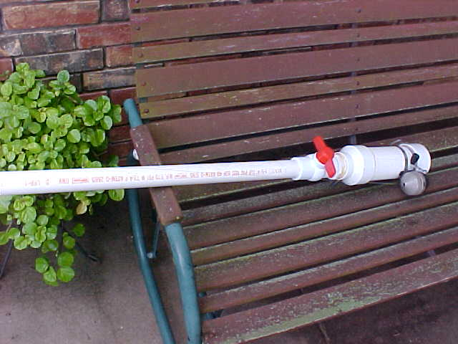 |  | 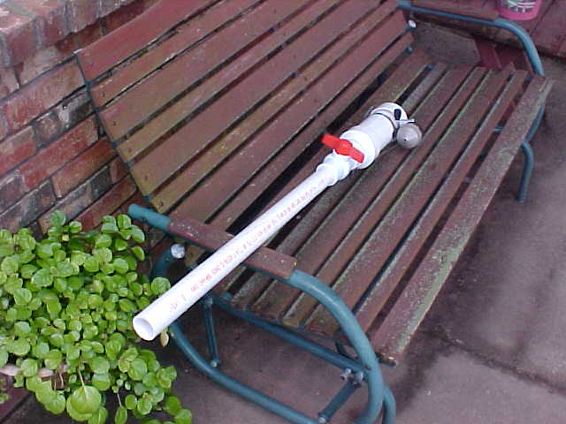
The complete Antenna Launcher stands about 4 feet tall. I do plan to move the Zebco reel from the rear up to the top of the smaller-diameter barrel piece to provide more control over the line connected to the flying projectile. (Yes, I know my patio glider needs to be repainted)
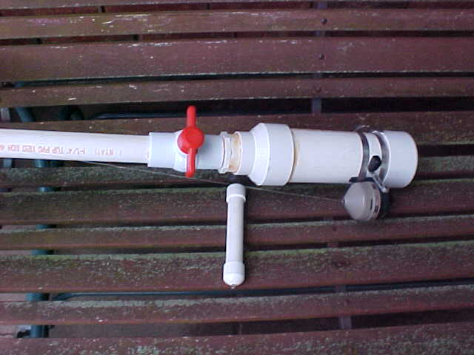 |  | 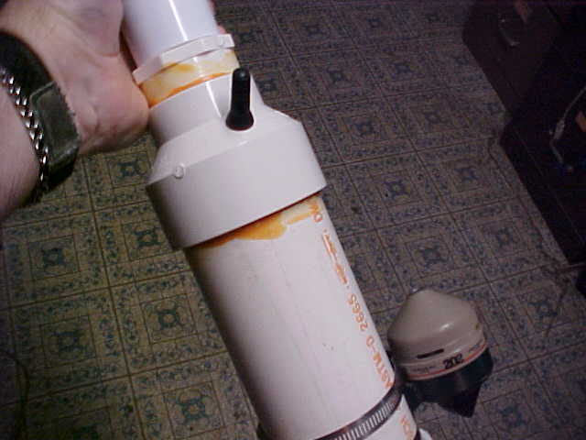
I used PVC tube cement to attach the ends of the air reservoir but left the barrel uncemented to the launch valve piece to make the launcher more portable for transportation and storage. The projectile has a small metal hook on one end to attach the fishing line and also the colorful streamer. |  | The Schrader valve, the same used for millions of automobile tires, is used to fill the air reservoir with the propulsion gas – plain old air.

The JARC Antenna Launcher was introduced at the Joplin Hamfest in about August of 2010 and was/is offered as a kit. The pieces are cut to the proper fit, the Schrader air valve is already installed and the user only needs to glue the pieces together, find an old fishing reel with some not-too-tangled monofilament fishing line, and assemble the pieces. The kit comes with two missiles, or projectiles, which are also made from PVC pipe material with a metal loop in one end. The included instructions suggest that the user might want fill the projectile with some additional weighted devices to give it the extra mass to “clear tall buildings (and trees) in a single bound.” The user could use small pieces of gravel, various sized fishing weights, or I suppose even gold nuggets if nothing else seemed handy. For shorter trees, just the weight of the projectile’s PVC pieces should be sufficient.

If the builder does not have an old inexpensive fishing reel, an old favorite Zebco model 202 should be available brand new for less than $10. A visit to a garage sale or a Goodwill store will probably turn up one so cheap that you might want to offer the seller some extra money, just because their asking price was so low.

I will say that I own one of these launchers, which I won at one of the Joplin Hamfests but I’m embarrassed to say that I’ve never used mine. I built mine up and supplied an old Zebco reel, which I attached to the lower end of the air reservoir. I’ve later learned that the reel could better serve the launcher if clamped to the upper part of the barrel where the air-driven projectile exits the gun. I plan to move the reel on my launcher as soon as I get around to picking up a couple of smaller stainless steel worm-gear clamps. In the pictures you’ll notice that mine is still located on the air reservoir. Since I can’t get around much any more I’m not doing any antenna work so this launcher becomes more the example for this article instead being the center of several examples of launching wondrous antennas at my station.

I did test the air holding capabilities of the unit and I pumped it up to about 50 pounds of air pressure with an AC operated compressor, testing it with a standard tire gauge. After a full week, I testing the pressure again and it still showed the same 50 pounds pressure so I’m quite confident of the “pressure valve” or “launch valve” or whatever is the appropriate name for it (that big red propeller-looking object).

The JARC sells their Antenna Launcher kit for $35 in person (at a hamfest) or $40 if they need to mail one to you. Their website information can be found at:
http://www.joplin-arc.org/pages/antennalauncher.html

You can see additional pictures of the Launcher as well as see a club-produced video showing it in action, at the website above. Orders can be placed at:
Joplin Amateur Radio Club

P.O. Box 2983
Joplin, MO 64803-2983

Do you look longingly at that big tree in your backyard and wish you could get a good piece of rope over the very top to attach your ideal experimental wire antenna? The Joplin ARC Antenna Launcher might just be what you’re looking for………….. quick, easy, effective, inexpensive, and readably available.

If the club would like to borrow my Antenna Launcher for Field Day use, it’s certainly available. I’d even gladly lend it out to other club members who’d like to try it at their QTHs but I think, for the price, quite a few folks will want one of their very own…… after all……….. what ham plans a long time in advance for the installation of a wire antenna they need? You think about it…………. you do it………….. If you had your own in the corner of your garage, it just helps to speed up your project.

73,
Jim – K5LAD

